Title: Airline Tickets

**Background**

Have you ever travelled by airplane or booking a plane ticket? Let try how to make a website for booking online an eticket.

**Program Specifications**

Program an airline tickets, detail functions of this website is described below

**Features:**

This website contains 4 main functions; there are two kind of users: guests and registered users.

As the registered users you are allowed to use all functions of system.

As the Guest you are allowed to use function 5 only.

* Function 1: Home page  ( see figure 01)
* There are three menu on navigation bar: Home (current page), Book, Manage Booking and added two small menu on the right top of the website named Login and Register
* To be able to use the function of each menu, users are required to login the system first. If you wish to have an account, you can make a new one by click on hyperlink Register
* Function 2: Login page ( see PIC 02)
* Function 3: Booking page ( see PIC 03)
* Firstly, search for a flight that you wanna book, including departure date and return date. You book flight for yourself only.
* After select the flight and click on **Save** button, save information of Flight to database and automatically generate the booking number or reservation code of booking.
* Function 4: Manage Booking  ( see PIC 04)
* Display information of all bookings that you have just done.
* Function 5: Register a new user  ( see PIC 05)
* Register a new user

Note: All data must be load from database, not hard code.

***Expectation of User interface:***

Pic 01: Home Page ( TOP)

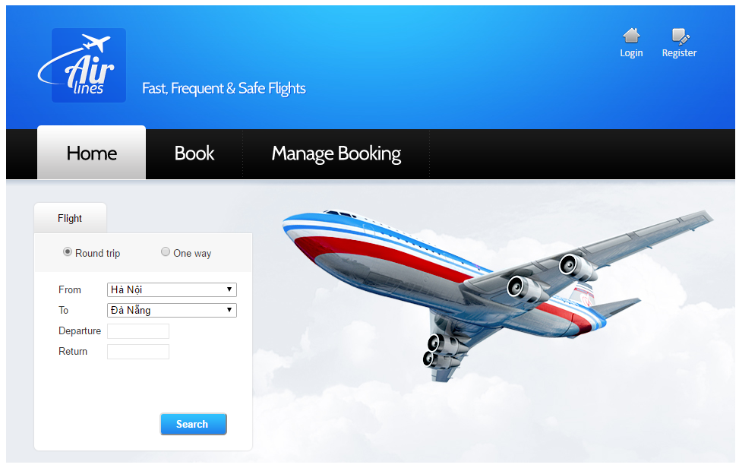

PIC 02: Login Page

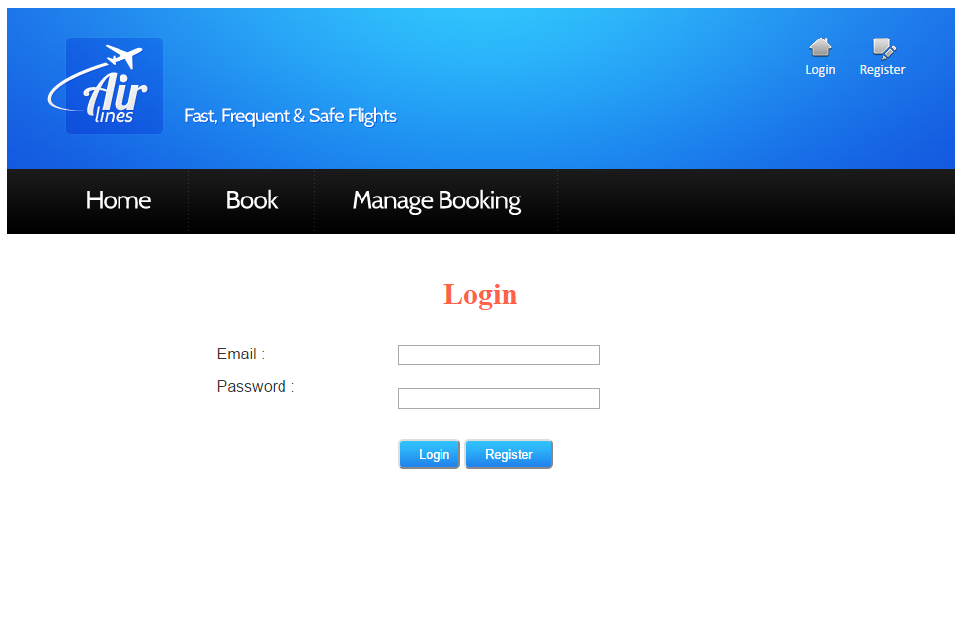

Pic 03: Booking page

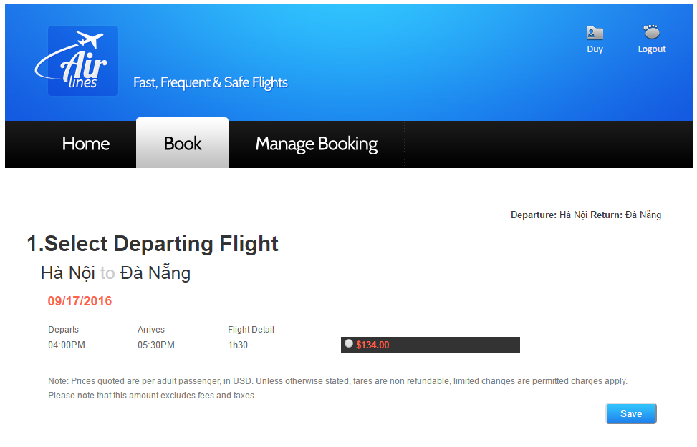

PIC 04: Manage Booking

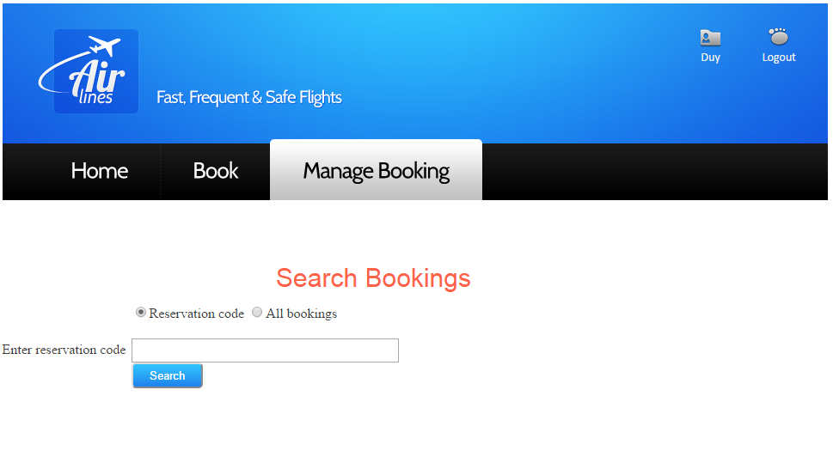

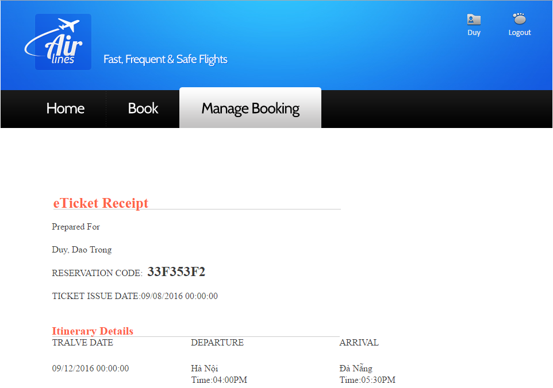

PIC 05: Register Page

